


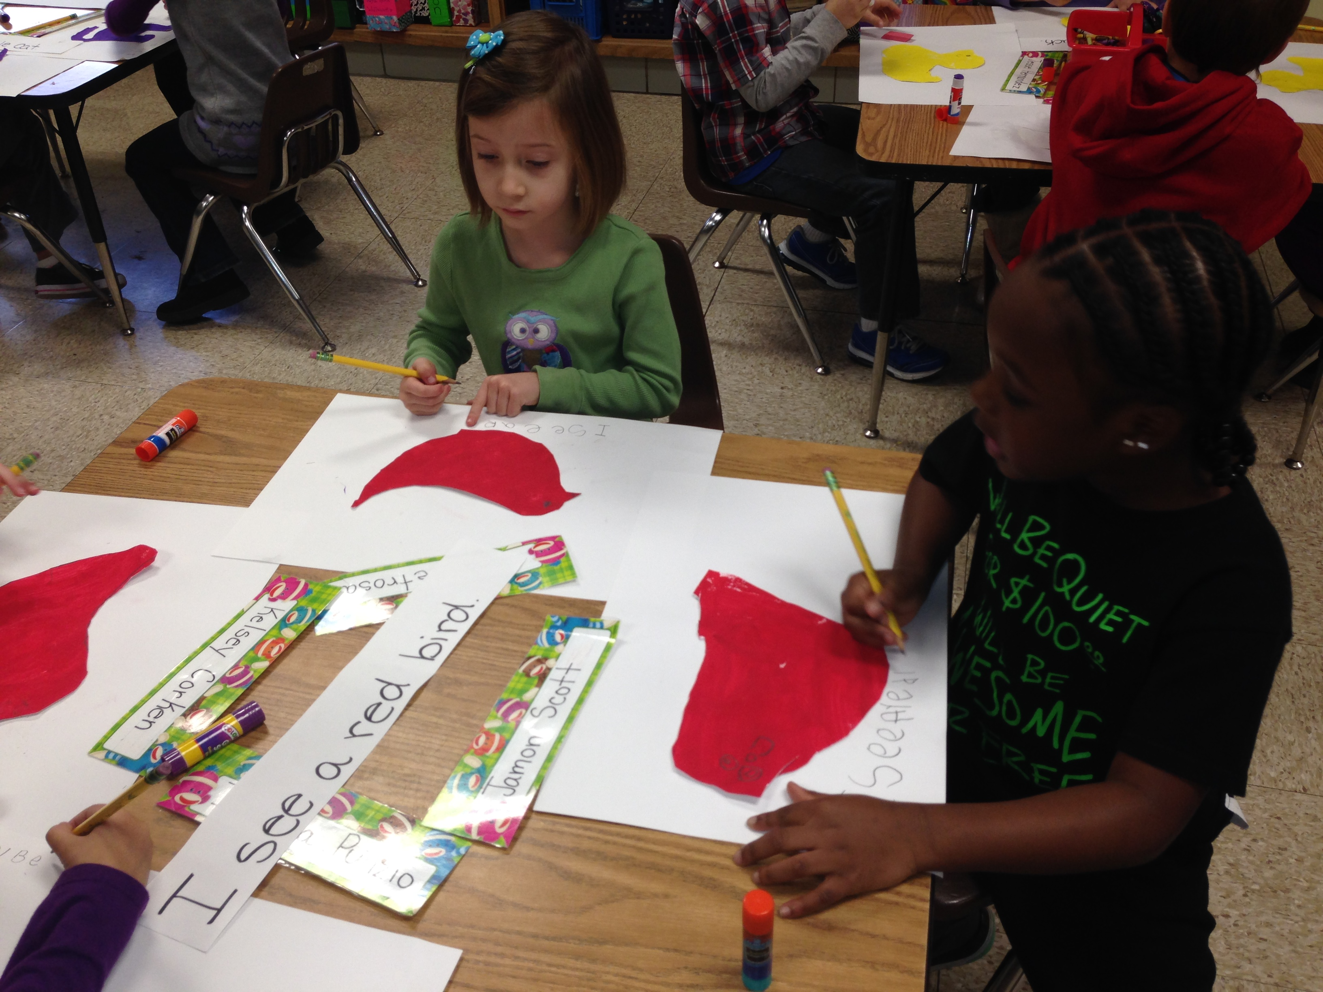
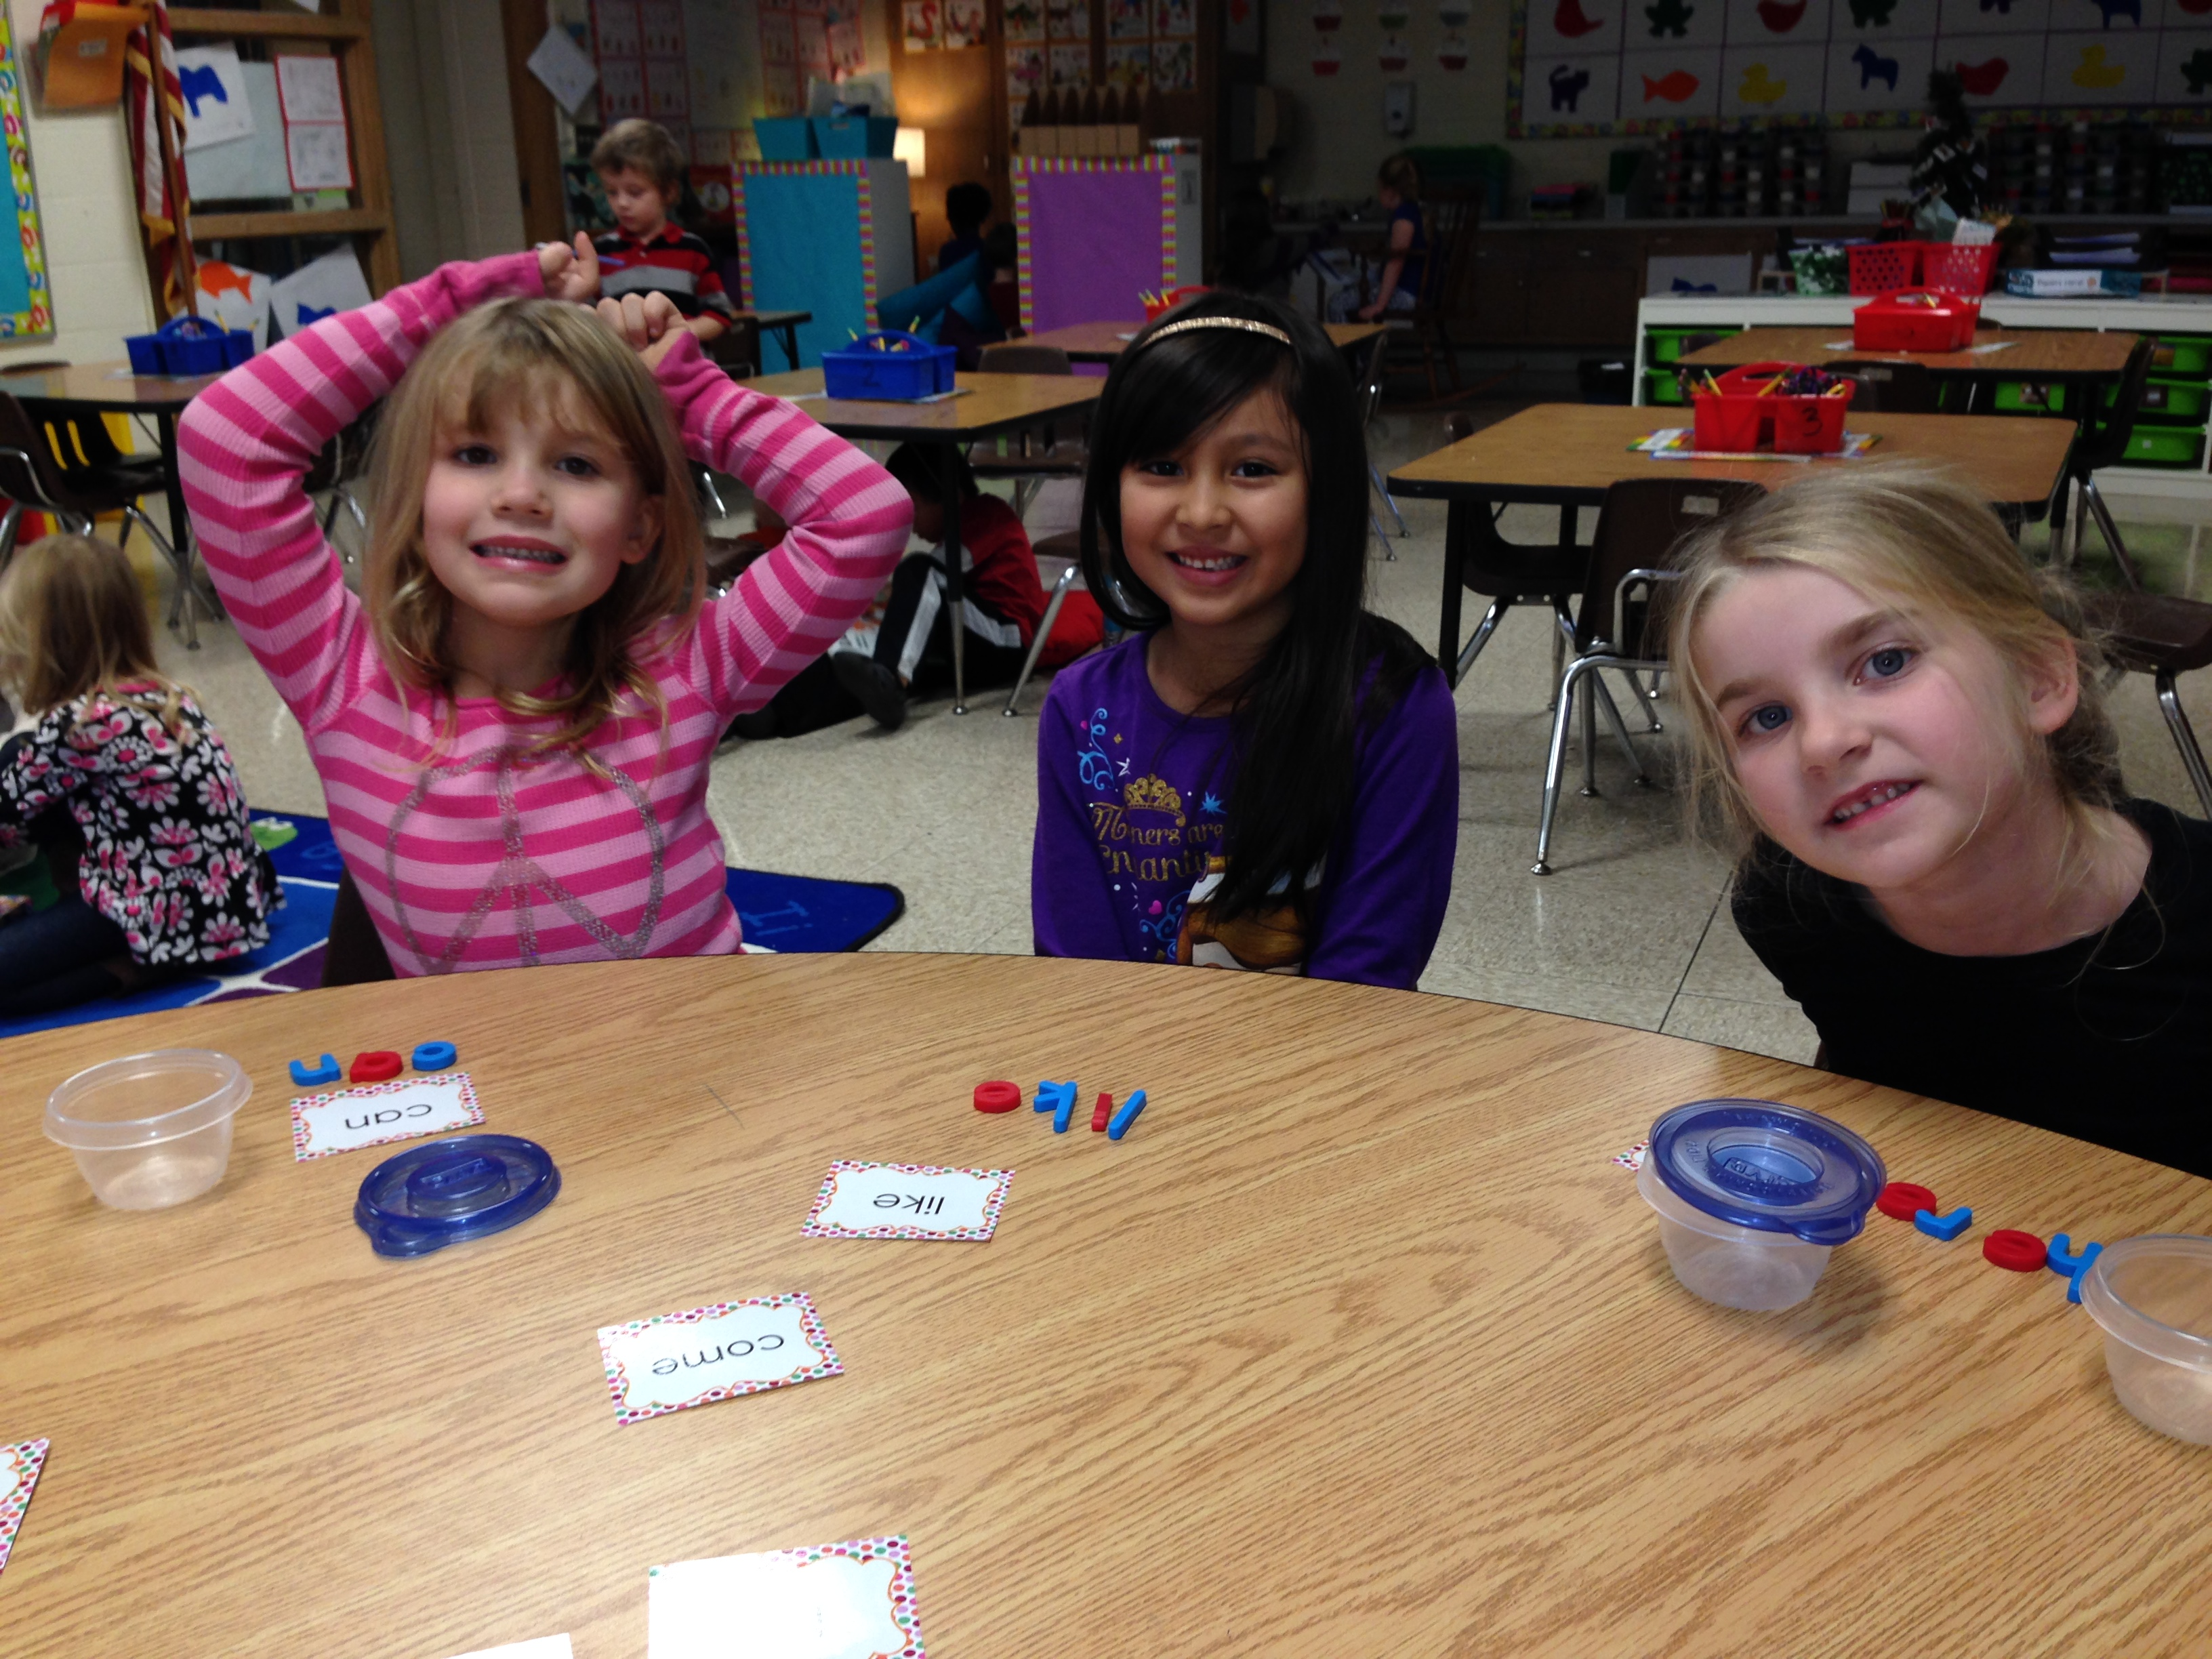
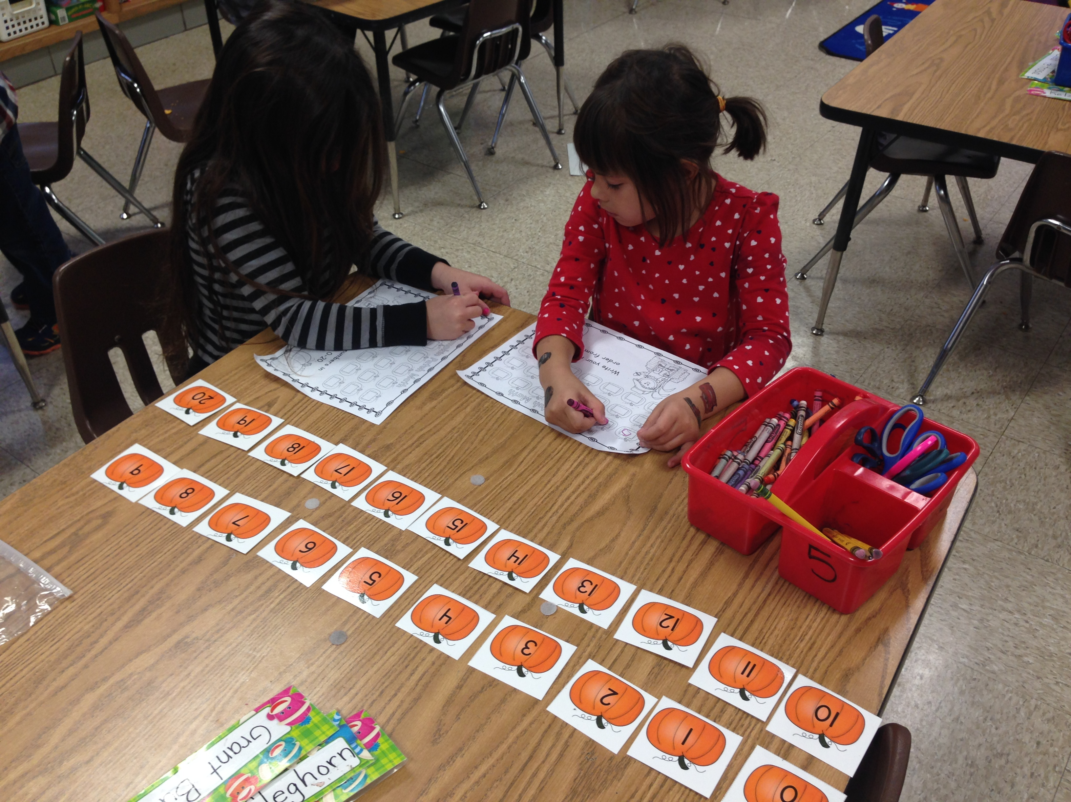

Mrs. Martinez
richelle.martinez@bps101.net
630-731-3910

Mrs. Martinez
richelle.martinez@bps101.net
630-731-3910

Brown Bear, Brown Bear

In the month of November Kindergarten studied the book Brown Bear, Brown Bear What Do You See? written by Bill Martin and illustrated by Eric Carle. The class discussed the technique Eric Carle used to create his trademark illustrations. The students painted a piece of paper, traced, and then cut an animal from the story. To complete their work, the students added a sentence at the bottom of their page.
Mix it, Fix it!

This month the students began pre-guided reading in small groups to build the foundational skills necessary to begin reading stories. In these groups the students worked on sight word practice, blending words, cvc words, letter recognition, and letter sounds. In the picture below, the students played “mix it, fix it” in which they had to mix the letters to their sight word and fix it to spell it correctly.

Heart Words!

Kindergarten has been working hard learning new sight words that we call “heart words” because we will learn, read, and know these words by heart! You can begin to practice these words at home with your child!

I like
can he
my to
go come
a here
you this
me
the

Pumpkin Counting!

Kindergarten has been practicing identifying and counting to 20. In this math game activity, the students worked with partners and used the pumpkin number cards to help them reinforce this skill. The students sorted the number cards and put them in order from 0-20. Then they wrote the numbers in order on their pumpkin worksheet.

