Mrs. Martinez - AM
Sunday | Monday | Tuesday | Wednesday | Thursday | Friday | Saturday
 |  |  |  |  |  | 1
2 | 3  Happy B-Day Bella & Dr. Seuss!  Day 2 | 4 Theater Field  Trip!  Day 3 | 5  Day 4 | 6  Day 1 | 7  Funway  All School  Skate!!  Day 2 | 8  Happy B-Day  Lukas G!
9 | 10  Day 3 | 11  Day 4 | 12  Happy  B-Day Grant!  Day 1 | 13  Day 2 | 14  Day 3 | 15
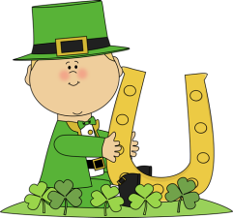  16 | 17  Happy St. Patrick’s day!  Day 4 | 18  Day 1 | 19  Day 2 | 20  Day 3 | 21  No School for Kindergarten | 22
23 | 24  Day 4 | 25  Day 1 | 26  Day 2 | 27  Day 3 | 28  Day 4 | 29
30 | 31 |  | Spring Break!

