



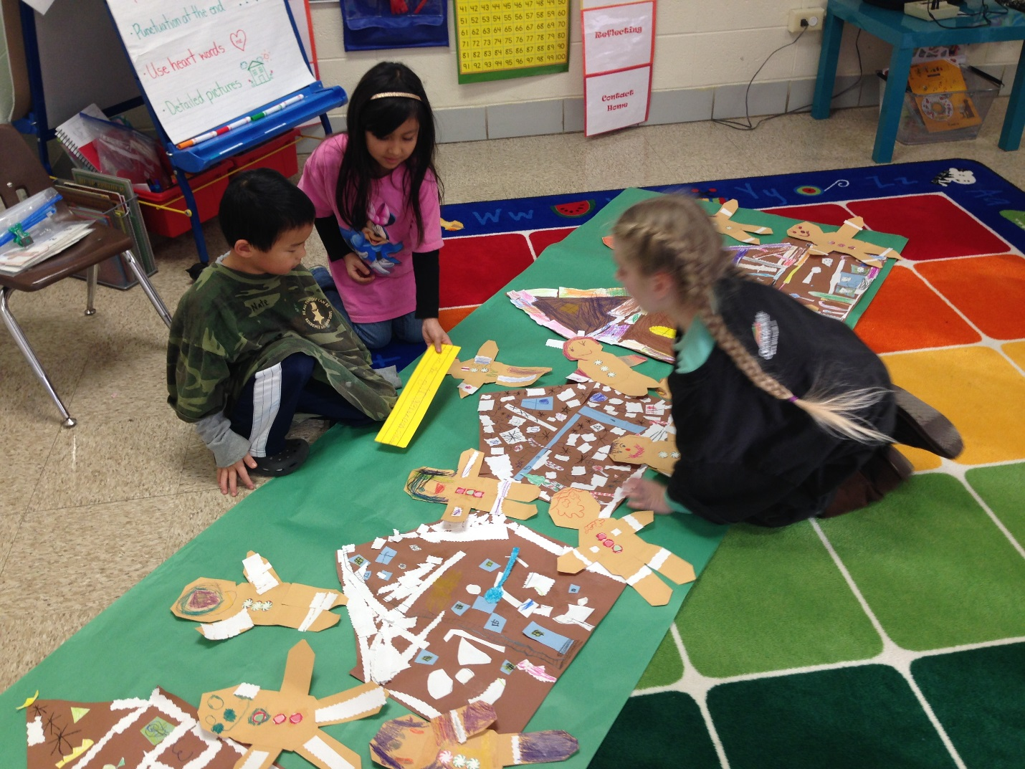
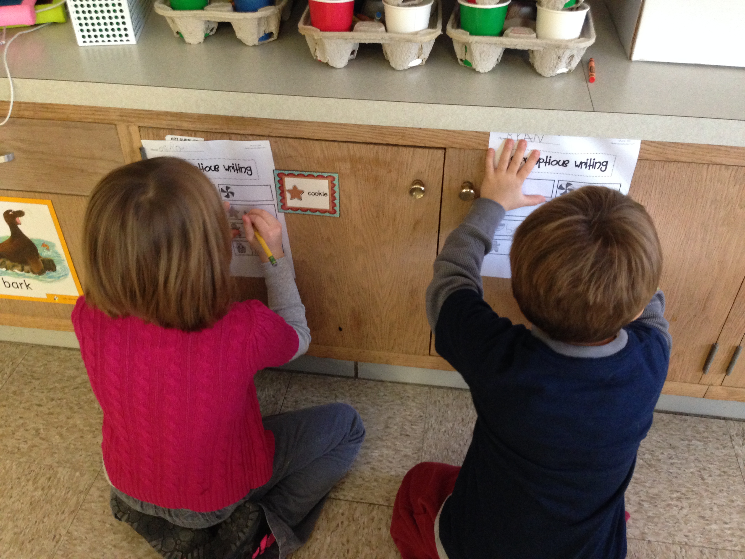
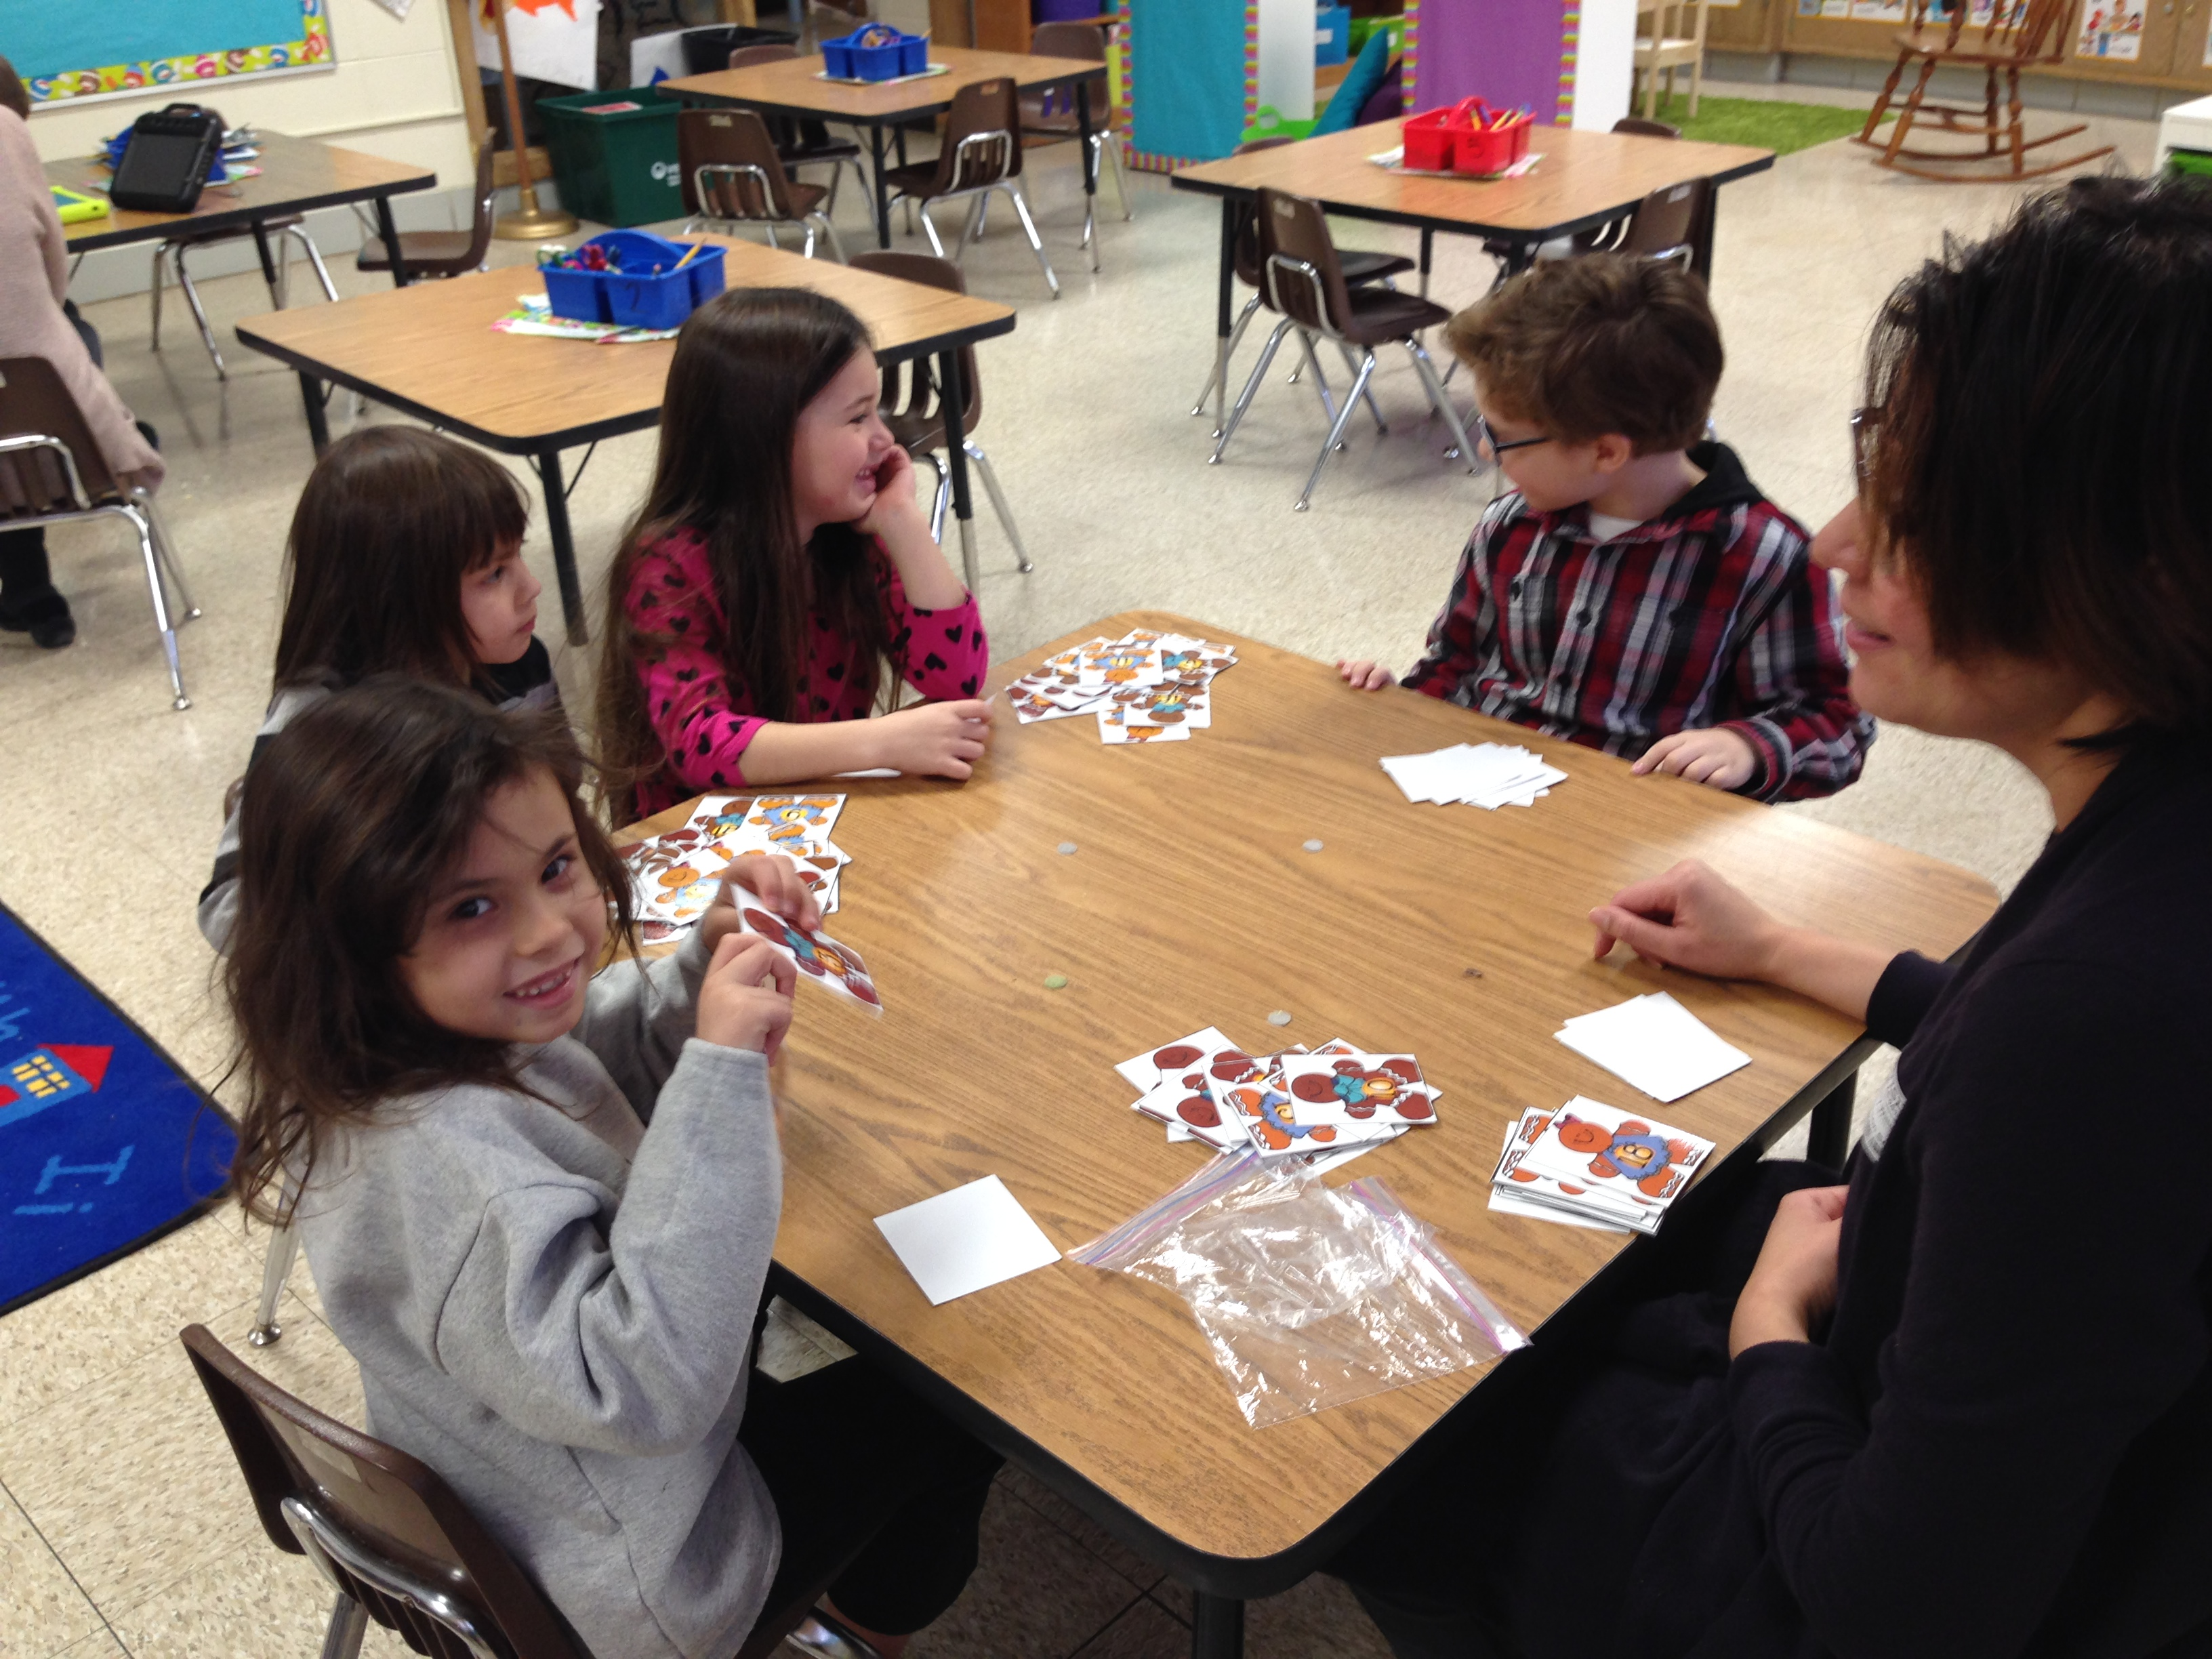
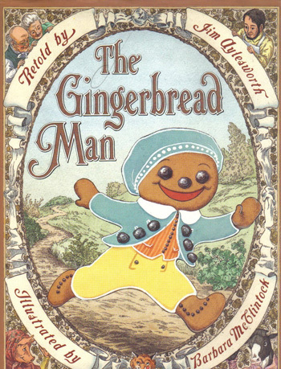
Run, run, as fast as you can!

In the month of December the Kindergarten students explored the many different versions of the Gingerbread Man story. We read the Gingerbread Man, Gingerbread boy, The Gingerbread Girl, The Gingerbread Baby, and even the Gingerbread Pirates! In this activity we made our own gingerbread people and houses to create a Gingerbread village! Then the students wrote phrases that the Gingerbread characters said in the books.
Scrumptious Word Hunt

In this activity the students went on a delicious word hunt throughout the classroom. They hunted high and low to find Gingerbread themed words. When they found the words they wrote them on their recording sheet.

Heart Words!

Kindergarten has been working hard learning new sight words that we call “heart words” because we will learn, read, and know these words by heart! You can begin to practice these words at home with your child! Here are the new heart words we learned in December!

for you
where do
see look

Gingerbread Top It

Kindergarten played this fun math game to help reinforce the concepts of identifying numbers 0-20. Mrs. Willuweit guided the students in this fun activity called Top It. Students placed their number cards down and the student with the highest number got to keep the cards.
Mrs. Martinez
richelle.martinez@bps101.net
630-731-3910
www.peacelovekindergarten.com

