Mrs. Martinez’ PM Class
Sunday | Monday | Tuesday | Wednesday | Thursday | Friday | Saturday
1 | 2  Day 1 | 3  Day 2 | 4  Day 3 | 5  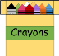  Day 4 | 6  Day 1 | 7  Breakfast with Santa!
8 | 9  Day 2 | 10  Day 3 | 11  Day 4 | 12  Day 1 | 13  Movie  Night!  Day 2 | 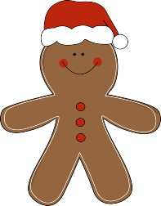  14
15 | 16  Day 3 | 17  Day 4 | 18  Day 1 | 19  Day 2 | 20  Winter  Party!  Day 3 | 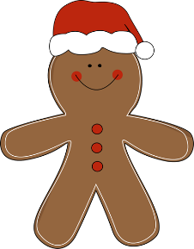  21
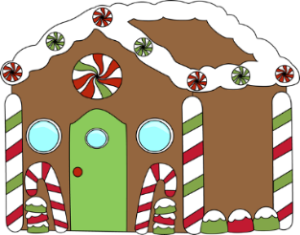  22 | 23 | 24 | 25 | 26  Have a Safe and Happy Holiday Season! | 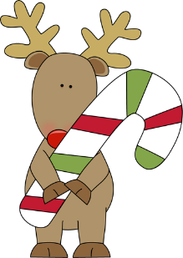  27 | 28
29 | 30 | 31

